**18CSC301 Operating Systems 3-0-2-4**

## DEPARTMENT OF COMPUTER SCIENCE AND ENGINEERING

**AMRITA SCHOOL OF COMPUTING**

**AMRITA VISHWA VIDYAPEETHAM**

# COURSE PLAN & STRUCTURE

## Academic Year: 2022-2023 Semester: 5

**Program: Integrated M.Sc. Data Science Course Code: 18CSC301**

## COURSE OVERVIEW

The course aims at teaching students understand the structure and implementation of modern operating systems, virtual machines and their applications. It summarizes techniques for achieving process synchronization and managing resources like memory, CPU, and files and directories in an operation system. It compares and contrasts the common algorithms used for both pre-emptive and non-pre-emptive scheduling of tasks in operating systems (such a priority, performance comparison, and fair-share schemes). It gives a broad overview of memory hierarchy and the schemes used by the operating systems to manage storage requirements efficiently.

## COURSE OBJECTIVES

* Provide an understanding on principles and modules of operating systems and the key mechanisms in design of operating systems modules.
* Understand process management, concurrent processes and threads, memory management, virtual memory concepts, deadlocks.
* Gain familiarity with algorithmic solutions to process synchronization problems, CPU scheduling.
* Explain various memory management techniques and concept of thrashing.
* Comprehend and apply disk management and disk scheduling algorithms for better utilization of external memory.
* Explain the various features of different OS like UNIX, Linux, windows, Android, ios etc.

## COURSE OUTCOMES

|  |  |  |
| --- | --- | --- |
|  | **Course Outcome** | **Bloom’s Taxonomy Level** |
| CO 1 | Understand the architecture and functionalities of modern  OS and virtual machines | L2 Understand |
| CO 2 | Understand and apply the algorithms for resource  management and scheduling | L3 Apply |
| CO 3 | Apply semaphores and monitors for classical and real world synchronization scenarios | L4 Analyze |
| CO 4 | Ability to engage in independent learning as a team to  study characteristic features of modern operating systems | L4 Analyze |

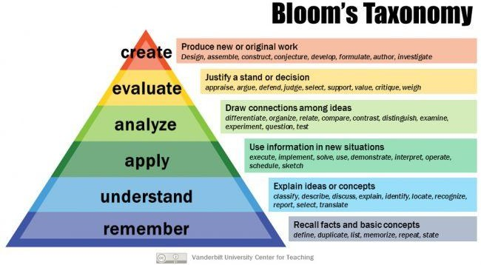

**CO – PO - PSO AFFINITY MAP**

|  |  |  |  |  |  |  |  |  |  |  |  |  |  |  |
| --- | --- | --- | --- | --- | --- | --- | --- | --- | --- | --- | --- | --- | --- | --- |
|  | PO1 | PO2 | PO3 | PO4 | PO5 | PO6 | PO7 | PO8 | PO9 | PO10 | PO11 | PO12 | PSO1 | PSO2 |
| CO1 | 1 | 1 | 1 | - | - | - | - | - | - | - | - | - | 3 | 2 |
| CO2 | 2 | 2 | 3 | 1 | - | - | - | - | - | - | - | - | 3 | 2 |
| CO3 | 2 | 3 | 3 | 1 | - | - | - | - | - | - | - | - | 3 | 2 |
| CO4 | 2 | 2 | 1 | 2 | - | - | - | - | 2 | 2 | - | - | 3 | 2 |

## CONCEPT MAP

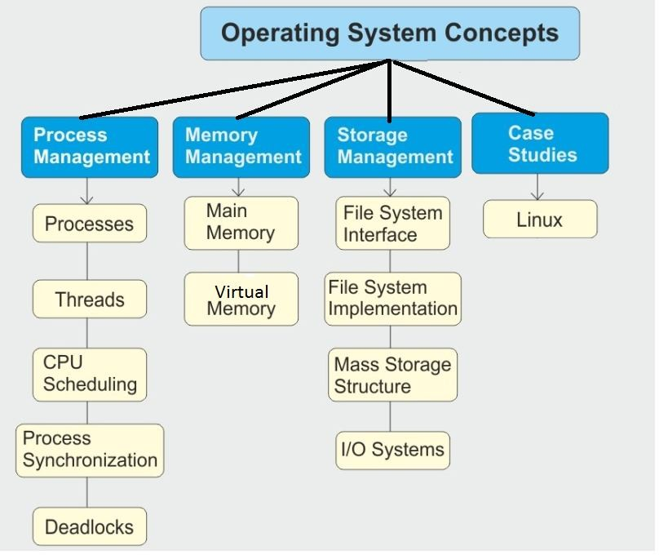

* 1. **SYLLABUS**

## 18CSC301 Operating Systems (3-0-2-4)

**Unit 1**

Introduction to operating systems: Overview – types of systems – computer system operations – hardware protection – operating systems services – system calls – system structure – virtual machines. Process management: process concepts – process scheduling – operations on process – cooperating process – inter-process communication – multi threading models – threading issues – thread types – CPU scheduling – scheduling algorithms.

**Unit 2**

Process synchronization: critical section problem – synchronization hardware – semaphores – classical problems of synchronization – critical regions – monitors – deadlocks – deadlock characterization – methods of handling deadlocks – deadlock prevention – avoidance – detection and recovery.

**Unit 3**

Storage management: memory management – swapping – contiguous memory allocation. Paging and segmentation – segmentation with paging – virtual memory – demand paging – process creation – page replacement – thrashing. File systems: directory structure – directory implementation – disk scheduling.

**Case study:** threading concepts in operating systems, kernel structures.

**TEXTBOOK:**

*Silberschatz and Galvin, “Operating System Concepts”, Ninth Edition, John Wiley and Sons, 2012.*

**REFERENCES:**

1. *Deitel. Deitel and Choffnes, “Operating System”, Third Edition, Prentice Hall, 2003.*
2. *Tannenbaum A S, “Modern Operating Systems”, Third Edition, Prentice Hall, 2007.*
3. *Stevens W R and Rago S A, “Advanced Programming in the Unix Environment”, Second Edition, Addison – Wesley, 2008.*
4. *Gary Nutt, “Operating Systems”, Third Edition, Addison Wesley, 2009.*

## 6. COURSE MODULES & TOPICS

1. Introduction to Operating Systems

Introduction

Operating System Structure and Operations Types of systems

System Calls

Virtual Machines

1. Process Management - Concepts

Process Concepts

Inter process Communication Multithreaded Programming Process Scheduling

1. Process Coordination

The Critical-Section problem

Peterson’s solution and synchronization hardware Semaphores

Classical Problems of Synchronization Monitors

Deadlocks

1. Memory Management

Swapping

Contiguous Memory Allocation Paging

Segmentation Segmentation with paging

1. Virtual Memory Management

Introduction Demand paging

Page Replacement algorithms Thrashing

1. Storage Management – File Systems

File Concepts Access Methods

Directory and Disk Structure Directory Implementation Allocation Methods

1. Secondary-storage Structure Disk structure

Disk Scheduling

## COURSE PLAN

|  |  |  |  |  |
| --- | --- | --- | --- | --- |
| **Lecture Hours** | **Topics** | **Objectives** | **CO** | **BTL** |
| **UNIT I: Introduction to OS, Process Management – Multithreading, CPU Scheduling** | | | | |
| 01-03 | Introduction to operating system.  Types of systems | Introduction to Operating Systems  Understand the different types of operating systems | CO1 | 2 |
| 04-06 | Computer system structures, hardware protection | Understand the operations of Operating systems  Overview of the protection and security of OS | CO1 | 2 |
| 07-11 | Operating system structures | Understand and study the operating system structures.  Study of system calls and implementation of system calls  Introduction to Virtual Machines | CO1 | 2 |
| 12-15 | Process management | Introduction to the concept of processes, operations on processes.  Overview of Interprocess Communication and how to implement it. | CO2 | 3 |

|  |  |  |  |  |
| --- | --- | --- | --- | --- |
| 16-20 | Threads | Overview of Threads, types and different threading issues. | C02 | 3 |
| 21-25 | CPU scheduling | Introduction to CPU scheduling concepts  Understand various CPU scheduling algorithms and solve problems and compare the performance of various scheduling algorithms | C02 | 3 |
| **UNIT II – Process Synchronization & Deadlocks** | | | | |
| 26- 30 | Process synchronization | Understand the concurrency concepts, critical-section problem and various solutions for CS problem.  Solve classical and real- world synchronization scenarios using semaphores and monitor concepts | C03 | 4 |
| 31-35 | Deadlocks | Overview of deadlock concepts and ways for handling deadlocks  Understand and apply Banker’s algorithm for handling deadlocks | CO3 | 4 |
| **UNIT III: Memory Management, Virtual Memory Management and File Systems** | | | | |
| 36-38 | Storage management- Memory management | Introduction to memory management concepts  Working of paging and | CO2 | 3 |

|  |  |  |  |  |
| --- | --- | --- | --- | --- |
|  |  | segmentation concepts |  |  |
| 39-41 | Virtual memory | Study of Demand paging and various page replacement algorithms for virtual memory management | CO2 | 3 |
| 42-45 | File systems | Study of various I/O structure and how to implement it. | CO2 | 3 |

**8. COMPONENT LAB EXERCISES**

* Basic Linux Commands
* Shell Scripts
* Process creation
* Process scheduling

## 9. EVALUATION PATTERN

|  |  |  |
| --- | --- | --- |
| **Component Name** | | **Weightage** |
| **Internal** | Periodical # 1 Examination | 15 |
| Periodical # 2 Examination | 15 |
| Quizzes & Assignments | 10 |
| Component Lab exercises | 10 |
| **Total Internal** |  | 50 |
| **External** | End Semester Examination | 50 |
| **Total External** |  | 50 |
| **Total (Internal + External)** | | 100 |